Task On RDS { Amazon Relational Database Service}

Task 1: Create MariaDB Database on EC2
Step 1: Launch 1 Instance
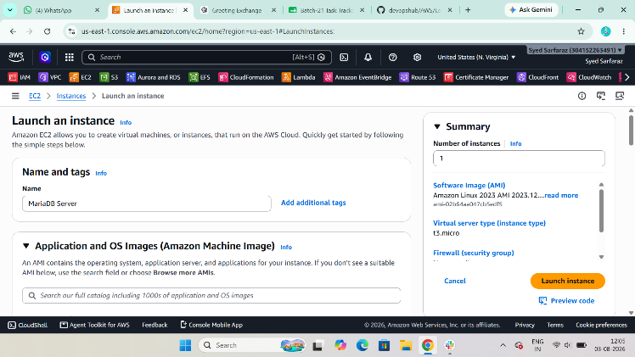

Step 2: Install MariaDB Server
sudo dnf install mariadb105-server -y
Purpose:
Installs the MariaDB database server.

Step 3: Start MariaDB Service
sudo systemctl start mariadb
Enable it on boot:
sudo systemctl enable mariadb
Check its status:
sudo systemctl status mariadb
You should see:
Active: active (running)
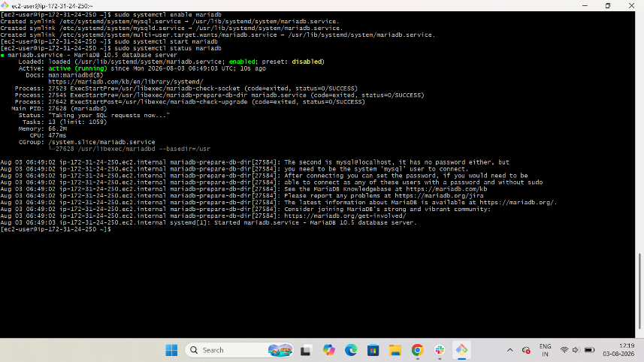

Step 4: Secure MariaDB
Run:
sudo mysql_secure_installation
Answer the prompts like this:
Enter current password:
Press Enter

Switch to unix_socket authentication? Y
Change the root password? Y
Enter new password: YourStrongPassword
Re-enter password: YourStrongPassword
Remove anonymous users? Y
Disallow root login remotely? Y
Remove test database? Y
Reload privilege tables? Y
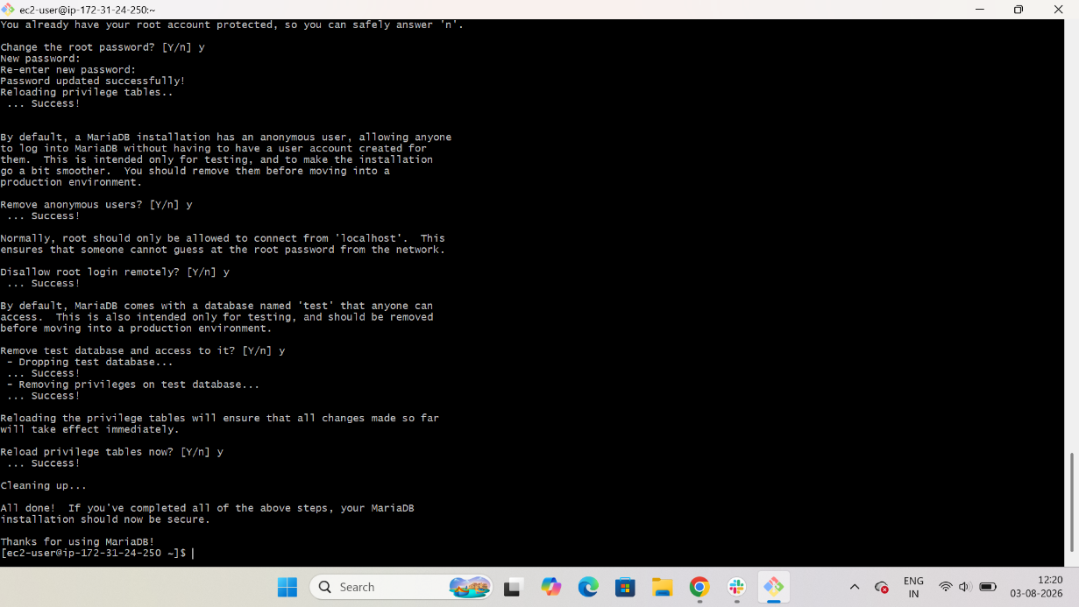

Step 5: Login to MariaDB
sudo mysql -u root -p
Enter the password you created.
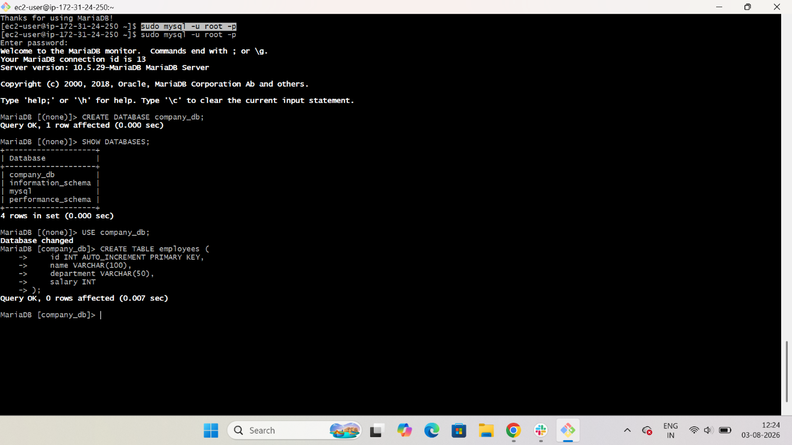

Step 6: Create a Database
CREATE DATABASE company_db;
Verify:
SHOW DATABASES;
You should see:
company_db

Step 7: Use the Database
USE company_db;

Step 8: Create a Table
CREATE TABLE employees (
id INT AUTO_INCREMENT PRIMARY KEY,
name VARCHAR(100),
department VARCHAR(50),
salary INT
);
Verify:
SHOW TABLES;
Output:
Employees
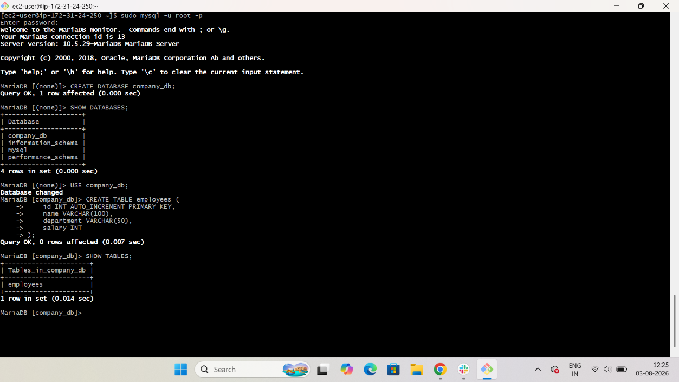

Task 2: Insert Dummy Data
INSERT INTO employees (name, department, salary)
VALUES
('Sarfaraz','DevOps',60000),
('Ali','Cloud',70000),
('Rahul','Linux',50000),
('John','Database',65000),
('Priya','Testing',55000);
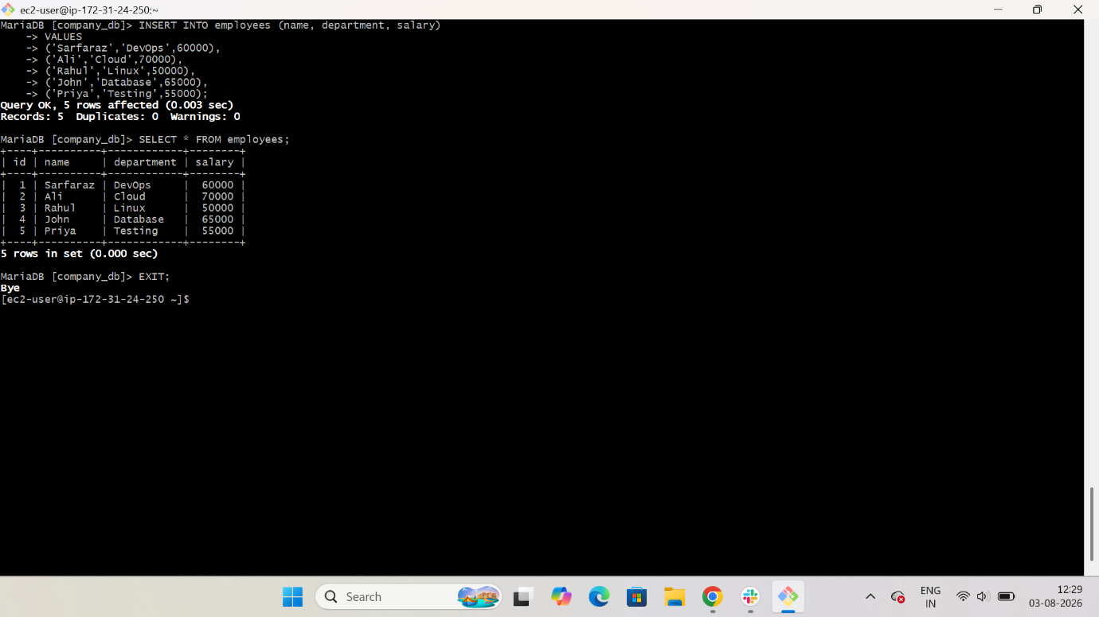

Step 1: Verify the Data
SELECT * FROM employees;
Expected output:
+----+----------+------------+--------+
| id | name | department | salary |
+----+----------+------------+--------+
| 1 | Sarfaraz | DevOps | 60000 |
| 2 | Ali | Cloud | 70000 |
| 3 | Rahul | Linux | 50000 |
| 4 | John | Database | 65000 |
| 5 | Priya | Testing | 55000 |
+----+----------+------------+--------+

Step 2: Exit MariaDB
EXIT;

Verify the Service
Check MariaDB is running:
sudo systemctl status mariadb
Check enabled on boot:
sudo systemctl is-enabled mariadb
Expected output:
Enabled
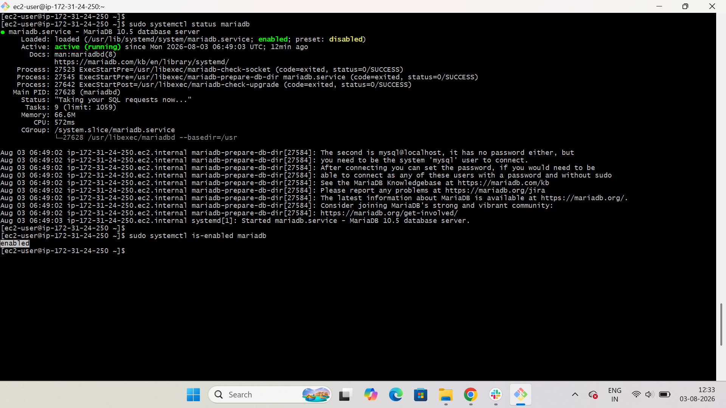

Commands Summary
sudo dnf update -y
sudo dnf install mariadb105-server -y
sudo systemctl start mariadb
sudo systemctl enable mariadb
sudo mysql_secure_installation
sudo mysql -u root -p
Inside MariaDB:
CREATE DATABASE company_db;
USE company_db;

CREATE TABLE employees (
id INT AUTO_INCREMENT PRIMARY KEY,
name VARCHAR(100),
department VARCHAR(50),
salary INT
);

INSERT INTO employees (name, department, salary)
VALUES
('Sarfaraz','DevOps',60000),
('Ali','Cloud',70000),
('Rahul','Linux',50000),
('John','Database',65000),
('Priya','Testing',55000);

SELECT * FROM employees;
EXIT;

Task 3: Take Backup of Dummy Data on EC2
Step 1: Take the Database Backup
Run the following command:
$ mysqldump -u root -p database name > database name bakup
Ex: $ mysqldump -u root -p company_db > company_db_backup.sql
Enter the MariaDB root password when prompted.
Purpose:
Creates a backup of the company_db database, including all tables and data, in the file company_db_backup.sql.
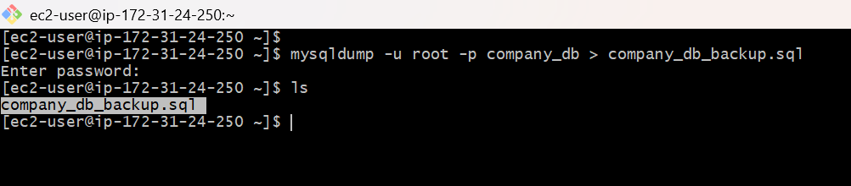

Step 2: Verify the Backup File
Run: $ ls -l company_db_backup.sql
Purpose:
Verifies that the backup file was created successfully.

Step 3: Verify the Backup Content
Run: $ head company_db_backup.sql
Purpose:
Confirms that the backup file contains SQL statements (database structure and data).

Task 4: Launch MariaDB RDS Instance
Step 1: Open RDS Console
- Login to AWS Console.
- Go to RDS.
- Click Create database.

Step 2: Choose Database Creation Method
- Standard create
Click Next.

Step 3: Select Engine
- Engine type: MariaDB
Click Next.
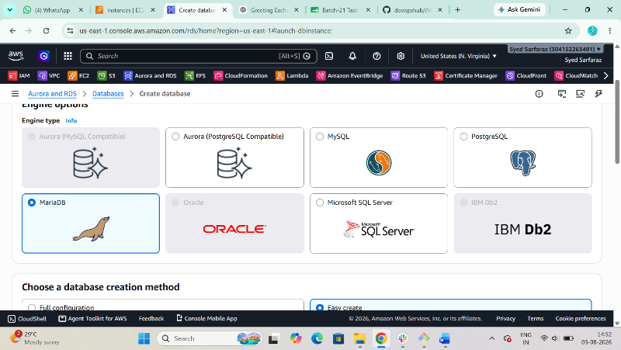

Step 4: Configure Database
Use the following values:
Setting | Value
DB instance identifier | mariadb-rds
Master username | admin
Master password | YourStrongPassword123!
Confirm password | YourStrongPassword123!
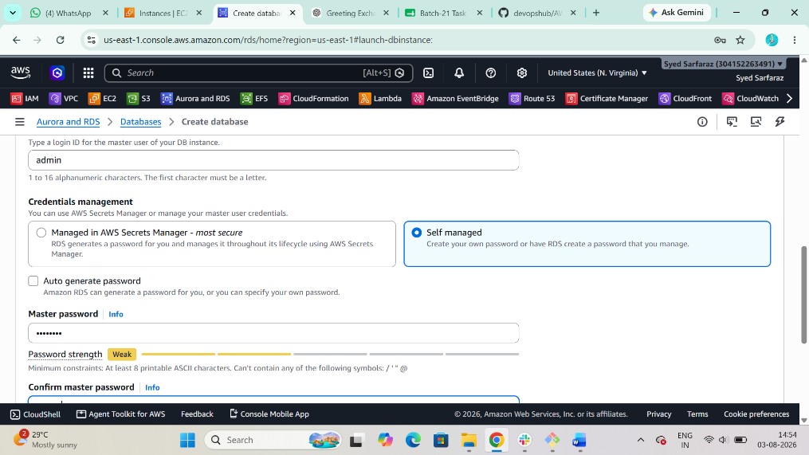

Step 5: Instance Configuration
- DB instance class: db.t3.micro (or Free Tier eligible if available)

Step 6: Storage
- Storage type: General Purpose SSD (gp3)
- Allocated storage: 20 GB

Step 7: Connectivity
Configure the following:
- VPC: Select the same VPC where your EC2 instance is running.
- Public access: No
- Security Group: Select an existing security group or create a new one.
Security Group Rule
The RDS security group must allow:
Type | Protocol | Port | Source
MySQL/Aurora | TCP | 3306 | EC2 Security Group
This allows your EC2 instance to connect to the RDS database.
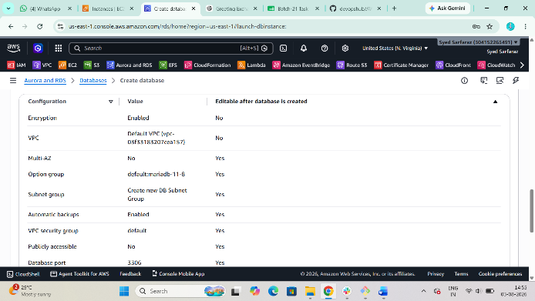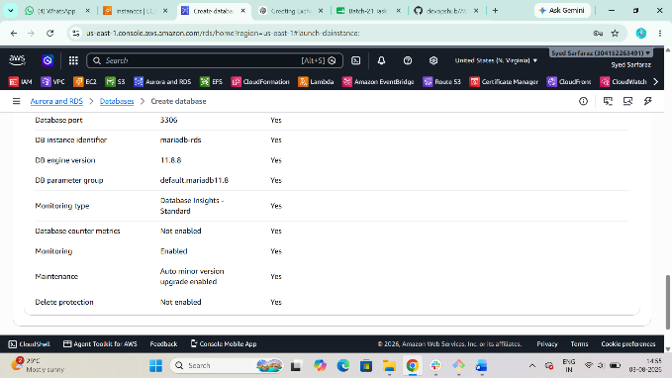

Step 8: Additional Configuration
- Initial database name: company_db
Leave other settings as default.

Step 9: Create Database
Click Create database.
Wait until the RDS status changes to Available.
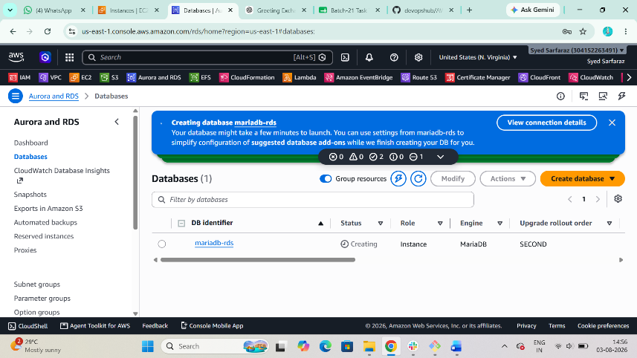

Step 10: Copy the RDS Endpoint
Open the RDS instance and copy the Endpoint, for example:
mariadb-rds.xxxxxxxxx.us-east-1.rds.amazonaws.com
You'll use this endpoint during migration.

Task 5: Migrate Database from EC2 to RDS
Step 1: Verify Backup File Exists on EC2
ls
You should see:
company_db_backup.sql
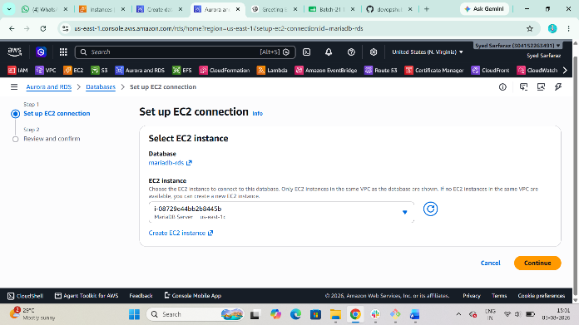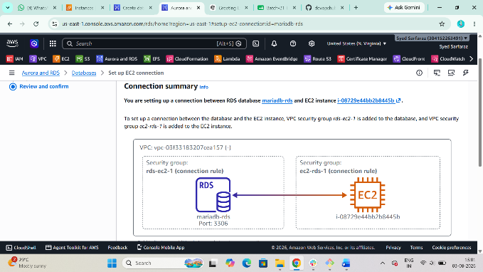

Step 2: Import the Database into RDS
Run the following command from your EC2 instance:
$ mysql -h <RDS-ENDPOINT> -u admin -p company_db < company_db_backup.sql
Example:
$ mysql -h mariadb-rds.xxxxxxxxx.us-east-1.rds.amazonaws.com -u admin -p company_db < company_db_backup.sql
Enter the RDS master password when prompted.
Purpose:
Imports the backup from the EC2-hosted MariaDB into the MariaDB RDS instance.

Step 3: Connect to the RDS Database
$ mysql -h <RDS-ENDPOINT> -u admin -p
Example:
$ mysql -h mariadb-rds.xxxxxxxxx.us-east-1.rds.amazonaws.com -u admin -p

Or Connect with Pem key
- Aurora and RDS>Databases> mariadb-rds> Connectivity & security> Code snippets
> Connection steps
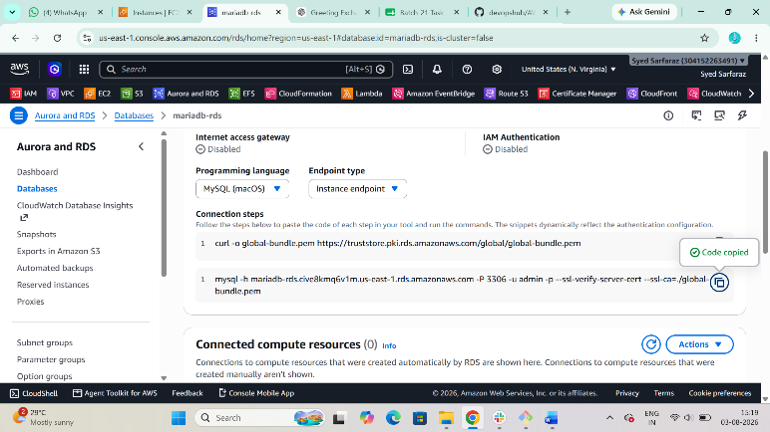
curl -o global-bundle.pem https://truststore.pki.rds.amazonaws.com/global/global-bundle.pem
mysql -h mariadb-rds.cive8kmq6v1m.us-east-1.rds.amazonaws.com -P 3306 -u admin -p --ssl-verify-server-cert --ssl-ca=./global-bundle.pem
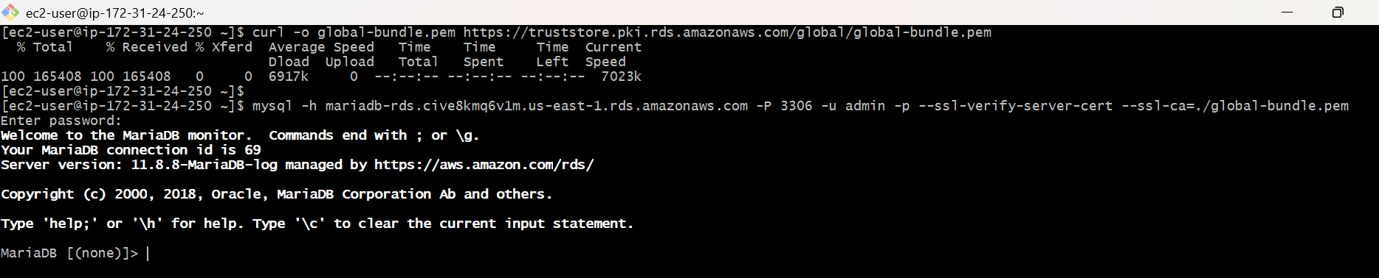

Step 4: Verify the Database
Inside MariaDB:
SHOW DATABASES;
You should see:
Company_migration
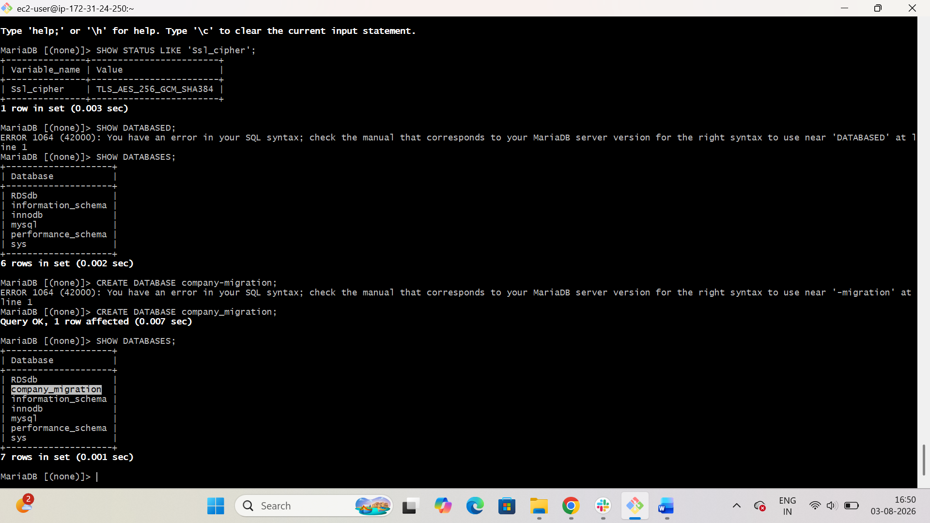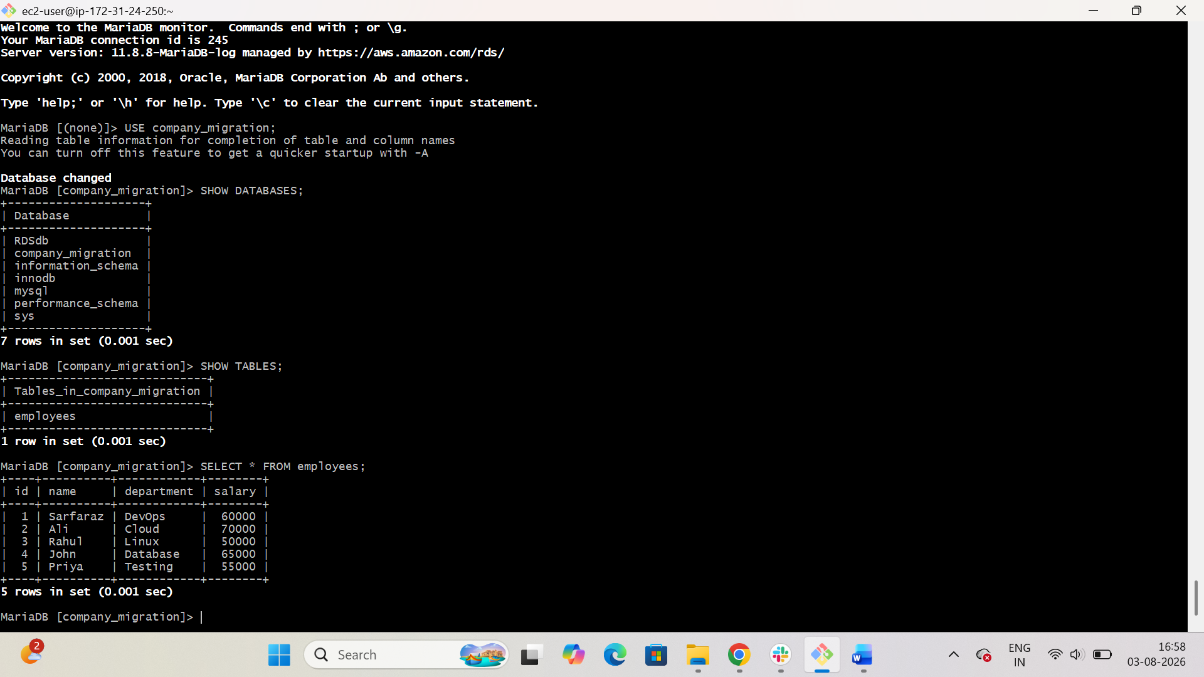

Task 6: Install MySQL Database on EC2
Update the System
Run:
sudo dnf update -y
Purpose:
Updates all installed packages to the latest version.

Step 1: Install the MySQL Community Repository
sudo rpm -Uvh https://dev.mysql.com/get/mysql84-community-release-el9-1.noarch.rpm

Step 2: Disable MySQL 8.4 Repository
sudo dnf config-manager --disable mysql-8.4-lts-community

Step 3: Enable MySQL 8.0 Repository
sudo dnf config-manager --enable mysql80-community

Step 4: Install MySQL Server
sudo dnf install mysql-community-server -y

Step 5: Start MySQL
sudo systemctl start mysqld

Step 6: Enable MySQL
sudo systemctl enable mysqld

Step 7: Verify MySQL
sudo systemctl status mysqld
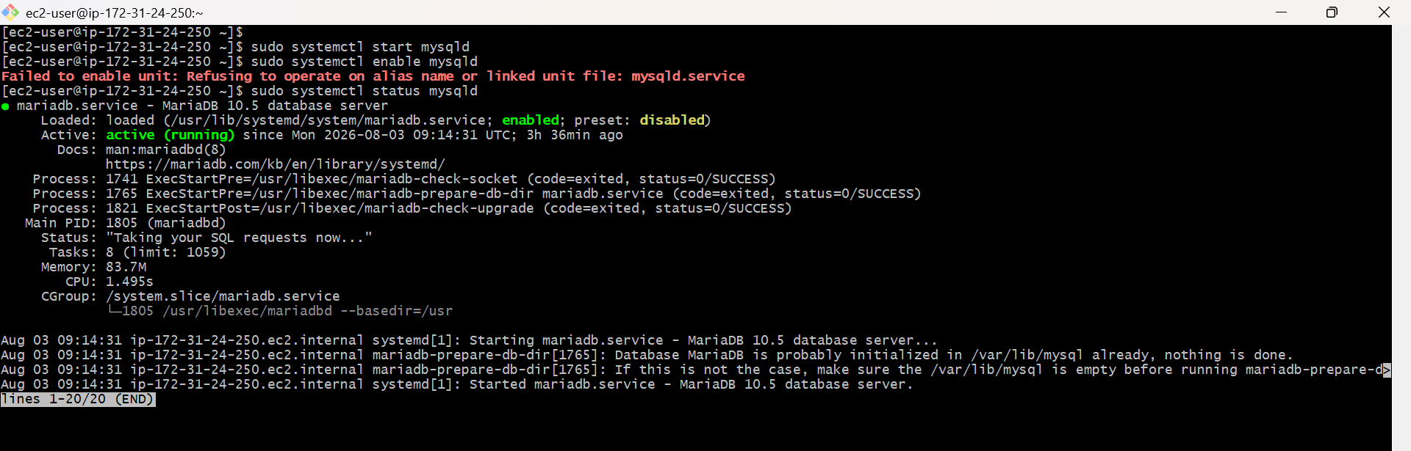

Task 7: Launch MySQL RDS Instance

Step 1: Open the RDS Console
- Sign in to the AWS Console.
- Go to RDS.
- Click Create database.
Purpose: Starts the creation of a new RDS database instance.

Step 2: Choose Database Creation Method
- Select Standard create.
Purpose: Allows you to configure all required settings.

Step 3: Select the Database Engine
- Engine type: MySQL
Purpose: Creates an Amazon RDS instance running MySQL.
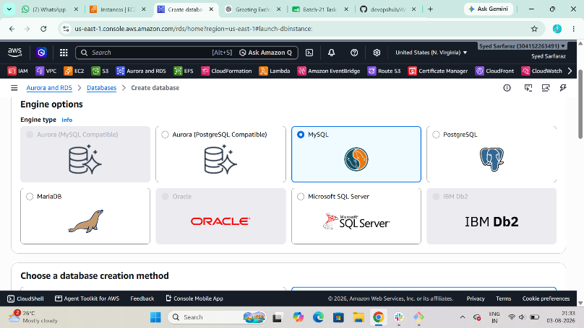

Step 4: Select the Engine Version
- Choose the latest available MySQL 8.0 version (or the version required by your task).
Purpose: Selects the MySQL version for the RDS instance.
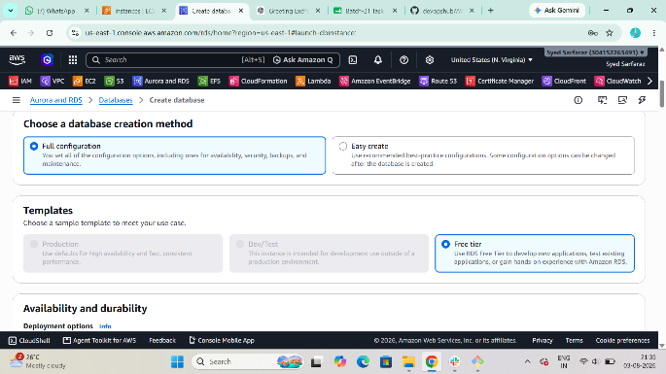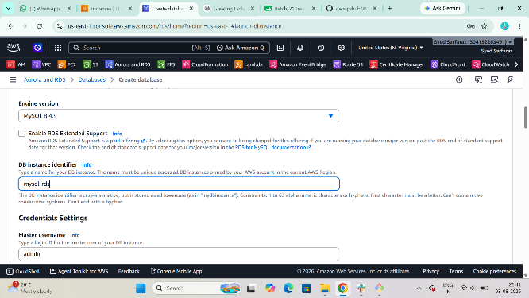

Step 5: Configure Database Credentials
Enter the following:
Setting | Value
DB instance identifier | mysql-rds
Master username | admin
Master password | YourStrongPassword123!
Confirm password | YourStrongPassword123!
Purpose: Creates the administrator account for the database.

Step 6: Configure Instance
- DB instance class: db.t3.micro (or the Free Tier eligible class available in your account)
Purpose: Selects the compute resources for the RDS instance.
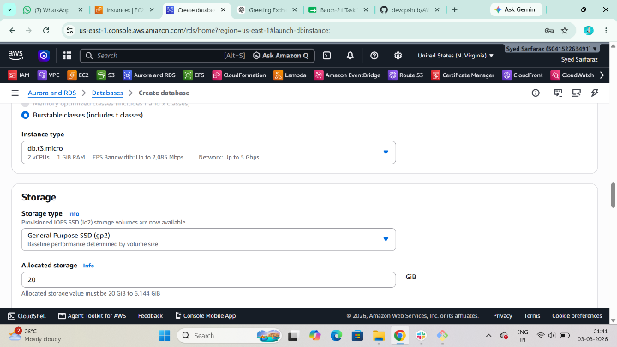

Step 7: Configure Storage
- Storage type: General Purpose SSD (gp3)
- Allocated storage: 20 GB
Purpose: Allocates storage for the database.

Step 8: Configure Connectivity
Set the following:
- VPC: Select the same VPC as your EC2 instance.
- Public access: No
- VPC Security Group: Select an existing security group or create a new one.
Add the following inbound rule to the RDS security group:
Type | Protocol | Port | Source
MySQL/Aurora | TCP | 3306 | EC2 Security Group
Purpose: Allows your EC2 instance to connect to the MySQL RDS instance.
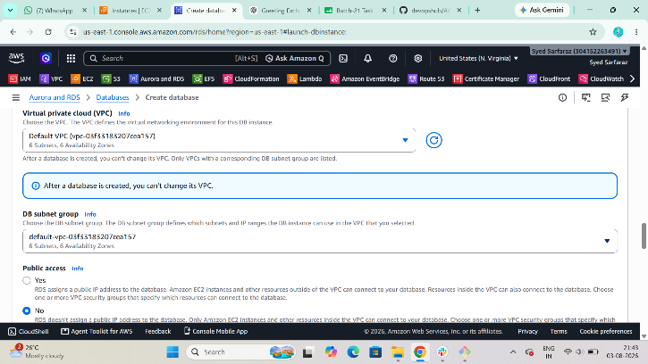

Step 9: Additional Configuration
- Initial database name: company_db
Leave the remaining settings as default unless your task specifies otherwise.
Purpose: Creates the initial database during RDS provisioning.
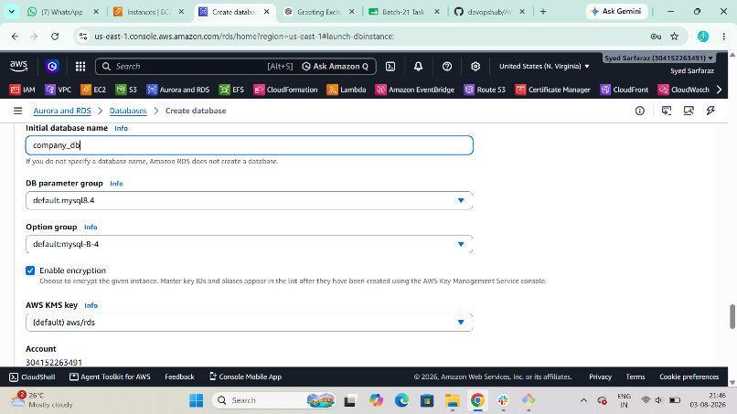

Step 10: Create the Database
Click Create database.
Wait until the Status changes to Available.
Purpose: Launches the MySQL RDS instance.
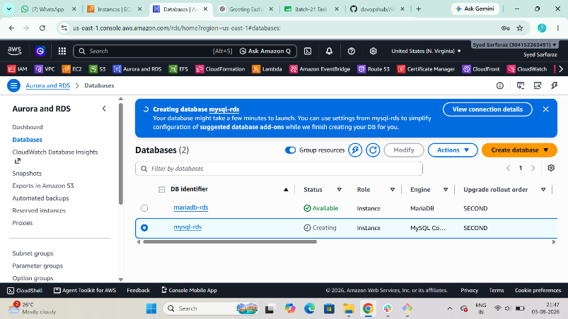

Step 11: Copy the Endpoint
Open the RDS instance and copy the Endpoint.
Example:
mysql-rds.cive8kmq6v1m.us-east-1.rds.amazonaws.com
Purpose: You'll use this endpoint to connect from your EC2 instance.
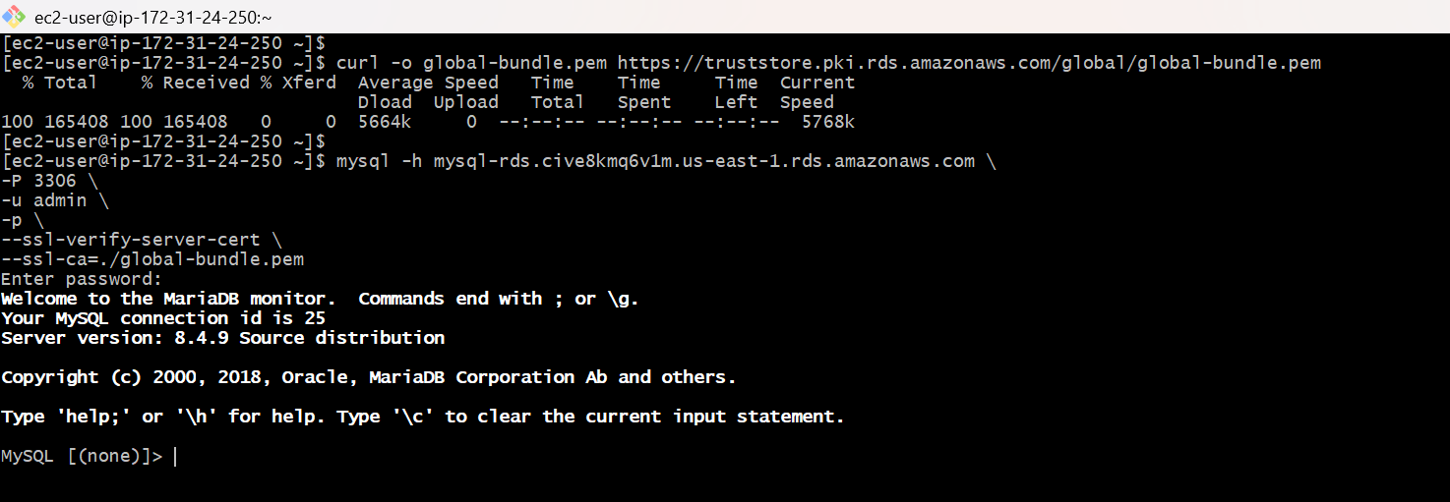

Step 12: Test the Connection from EC2
If Require secure transport is enabled on the RDS instance, download the AWS RDS CA bundle:
curl -o global-bundle.pem https://truststore.pki.rds.amazonaws.com/global/global-bundle.pem
Connect to MySQL RDS:
mysql -h mysql-rds.cive8kmq6v1m.us-east-1.rds.amazonaws.com\
-P 3306 \
-u admin \
-p \
--ssl-verify-server-cert \
--ssl-ca=./global-bundle.pem
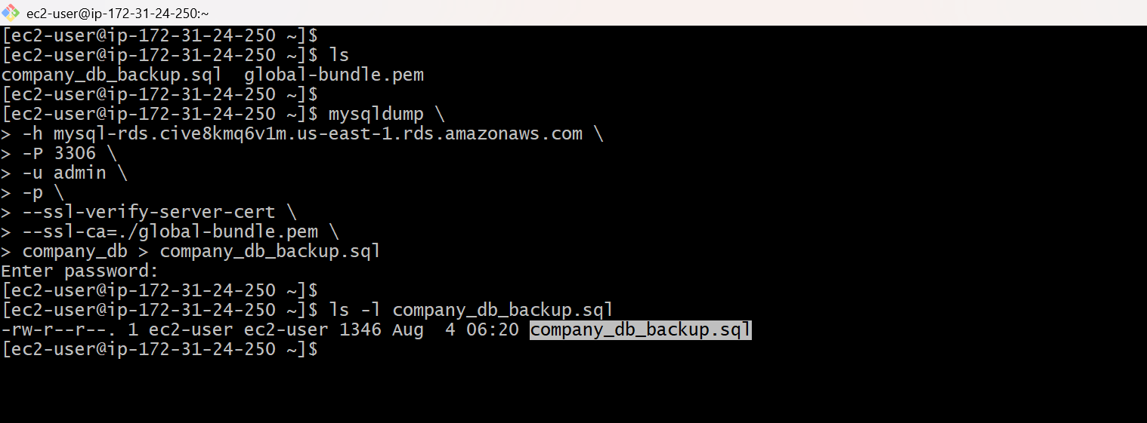

Task 8: Configure Multi-AZ.
Multi-AZ for Amazon RDS is a paid feature, Multi-AZ deployment is not supported under the AWS Free Tier.

Task 9: Backup Database
Manual Snapshot
RDS
Actions
Take Snapshot
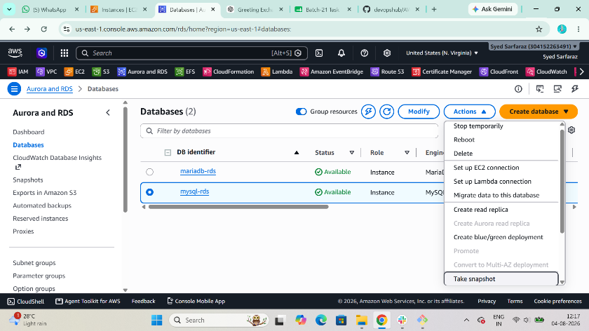
Name
mysql-backup
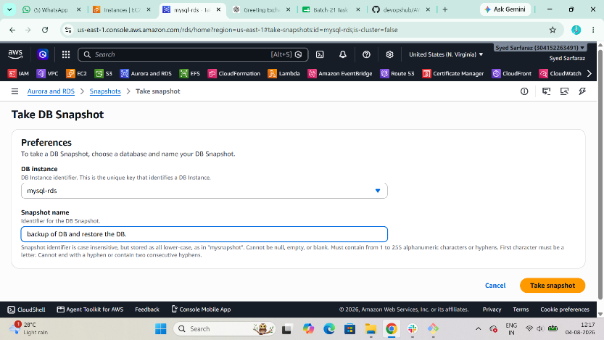
Create
Wait until completed
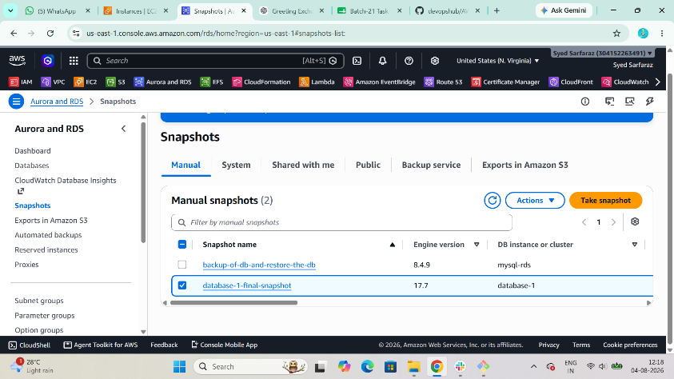
Task 9.1: Restore Database
RDS
Snapshots
Select Snapshot
Actions
Restore Snapshot
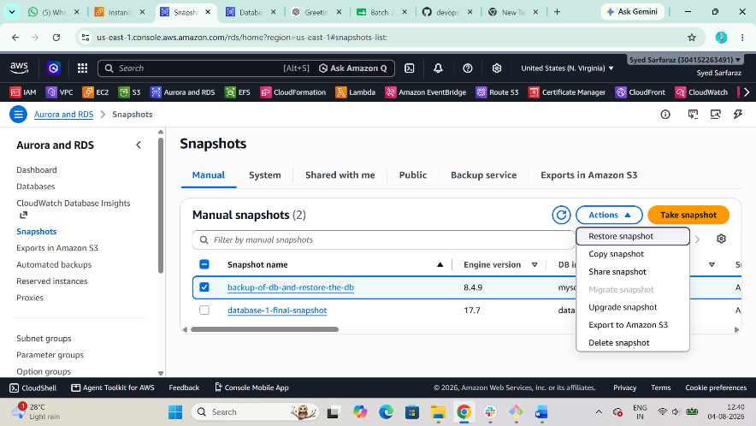
Provide
DB Identifier
Instance Class
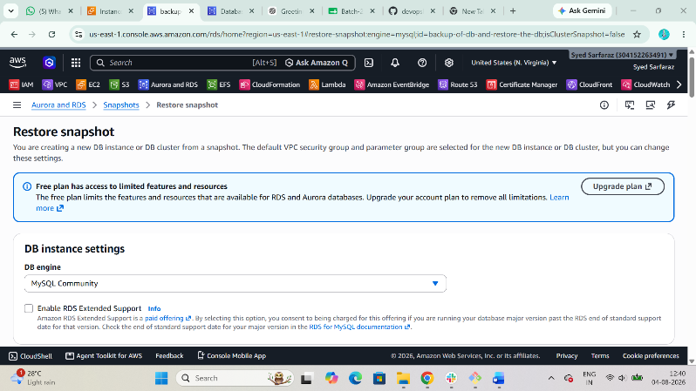
Restore
Wait until Available
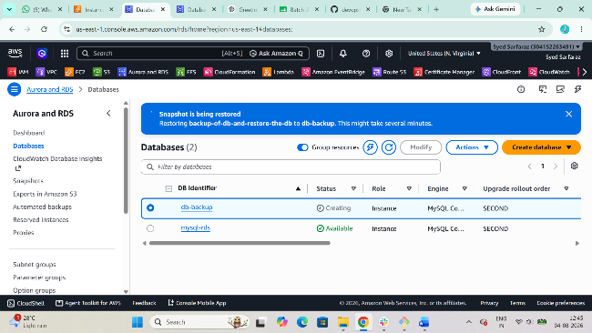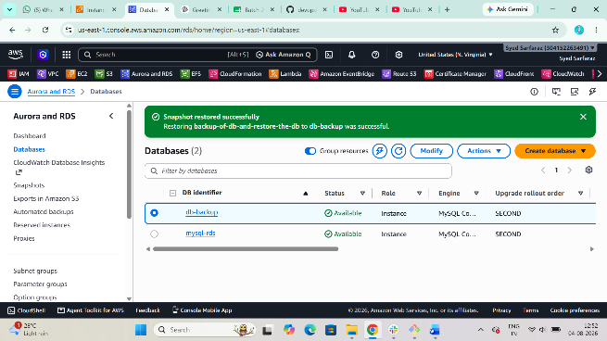
Task 10: Create Read Replica
RDS
Select MySQL DB
Actions
Create Read Replica
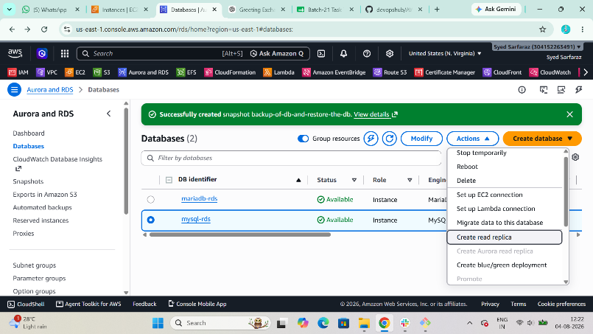
Choose
Same Region
Instance Class
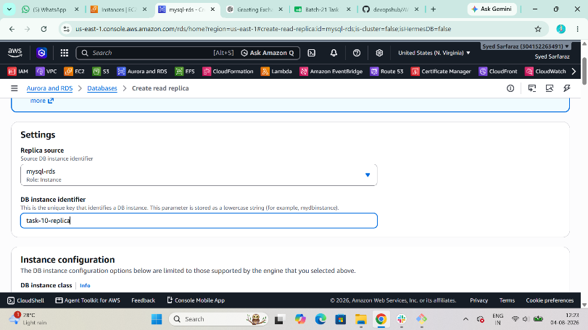
Launch
Wait until
Available
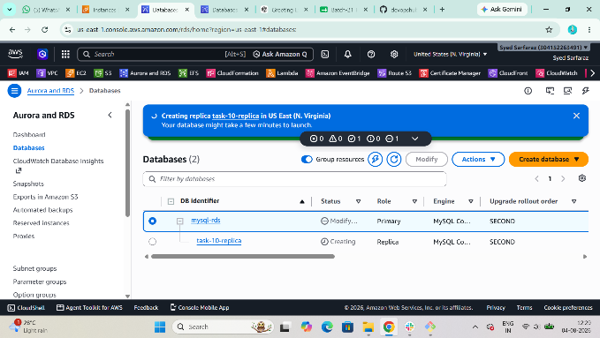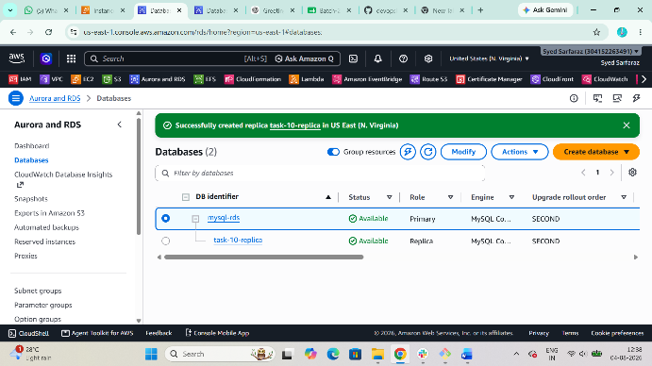

Architecture Diagram
+----------------------+
| EC2 Instance |
|---------------------- |
| MariaDB |
| company DB |
+----------+-----------+
|
mysqldump
|
company_backup.sql
|
|
Restore using mysql
|
v
+---------------------------+
| MariaDB RDS |
|---------------------------|
| company DB |
+-------------+-------------+
|
Snapshot Backup
|
Restore Snapshot
|
v
Restored MariaDB Instance
+--------------------------------+
| MySQL RDS |
|--------------------------------|
| Primary Instance |
| Multi-AZ Enabled |
+---------------+----------------+
|
Synchronous Replication
|
Standby (Another AZ)
|
Read Replica (Async)
|
Reporting / Read Queries

